
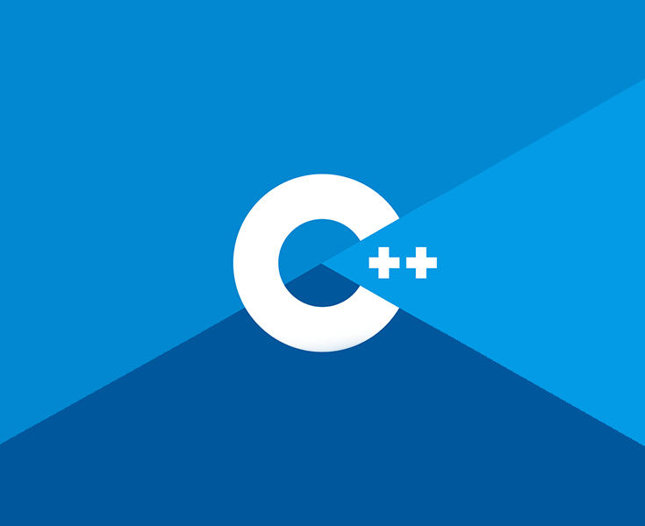
Game Engine Creation
COSE40638
Student Name: Petre Stefan
Student Number: 20022386
Portfolio

Contents

Chapter 1: Introduction
Chapter 2: Data Types
Chapter 3: Variables
Chapter 4: Operators
Chapter 5: Conditionals
Chapter 6: Loops
Chapter 7: Functions
Chapter 8: Arrays and vectors
Chapter 9: Strings
Chapter 10: Debugging
Chapter 11: Pointers
Chapter 12: References
Chapter 13: File Handling
Chapter 14: Object Orientated Programming – Structs
Chapter 15 OOP - Classes

Chapter 1: Introduction

To begin we will be going through the steps required to build a simple application in C++ using Visual Studio. This will be the traditional ‘Hello World’ program written by all new coders. This will go through the steps required to create a new program and how to add source files. If you followed along with the code-along then this section will just need a screenshot of your output.

NOTE: There is one function in the HelloWorld program. It is called main(). All programs must have a main function as this is where execution of the program begins. There can only be 1 main function in any given program.

Firstly, create a folder in your OneDrive and call it GitHub. Inside this create another folder called GEC. It is recommended you add folders for each week to make finding work easier, but this can be done later as needed.
Program 1: Hello World

- To begin, start Visual Studio and you will be met with this window…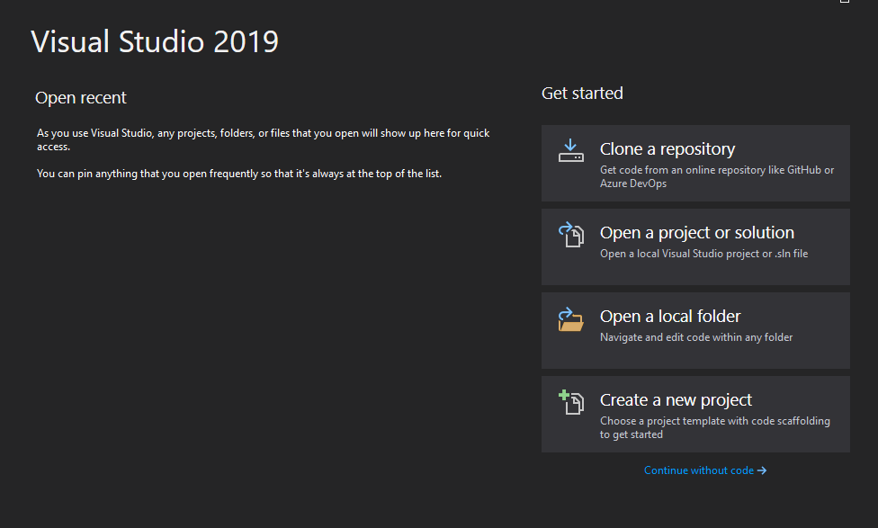

- Click Create a new project and select the C++ Empty Project and click Next.
- Name your Project HelloWorld and save to the location of your GEC folder within OneDrive that you created earlier, then click Create.
- You should have the following window open. Right click the folder Source Files -> Add -> New Item. The default can be left as it is, it should have C++ File selected with the name Source.cpp. Click Add 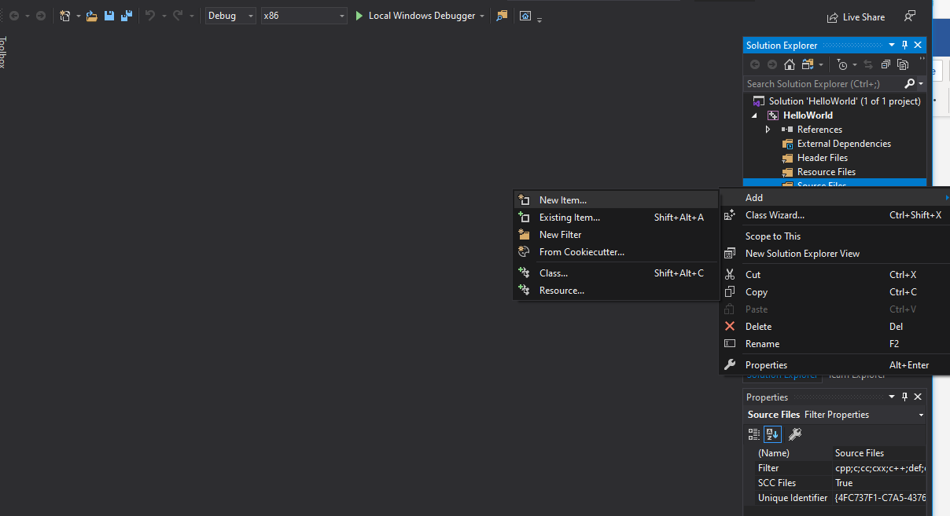
- Now for some code! Replicate the following code: 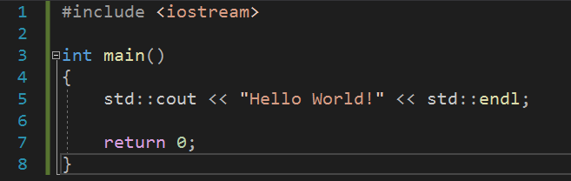
- The first line of code adds the input/ output streams library that contains the cout object that allows us to print to screen. As mentioned above, every program needs a main function as a point of entry. As you can see this function is of type int, this means that the function expects a return type of type int, as seen on line 7 where we return 0. This return is reached only if the function is completed. On line 5 we start with std:: this allows us to use the objects with the std namespace of the standard library, the use of std:: can be omitted if using namespace std; is added below our include, but for now lets use best practice and include them. After cout we have two left chevrons << when outputting these will face left, putting what is on the right of them to the screen. If we were taking information in from a user, they would face right. We will cover this later. We then end with endl; which is the same if we were to add \n for a new line and of course the semicolon which is needed to end a line of code. Keep an eye out for these as they are a common result for program errors from new coders.
- Now run your program using the green play button for Local Windows Debugger or F5. If you have followed along correctly you will be met with a console window containing “Hello World!”.
- Screenshot this and add it below.

Program 1 Screenshot:

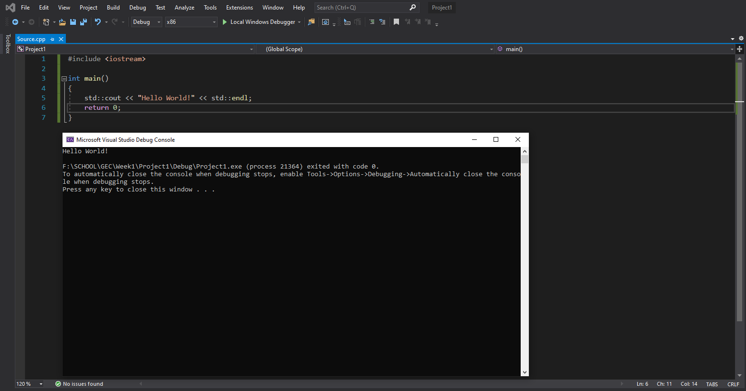

Chapter 2: Data Types

Before we can create variable to store our data, we need to learn what a data type is and how they work. There are a variety of built in data types that we can use immediately, but it is also possible to create your own.

This table details the data types that are found in C++ and you will be using throughout your studies.

Type | Keyword
Boolean | bool
Character | char
Integer | int
Floating point | float
Double floating point | double
Valueless | void
Wide character | wchar_t
Table 2.1: Data types

The keyword is how this type is written in C++. If you make a mistake typing this in, for example miss a letter or use an uppercase character where it should be lowercase you will be alerted to a syntax error.

Not: Syntax is the term used for how the compiler expects to receive the code. If something does not match, you will receive a syntax error.

Data Type Modifiers

Each type reserves a certain amount of memory from the computer. In some situations, you may find that you require the memory to be increased / decreased or you would like the value stored in a variable to be in a different range. To enable this there are data type modifiers.

Modifier | Description
signed | Use values in the negative and positive range.
unsigned | Use only the positive range.
short | Decrease the range, thus reducing the memory used.
long | Increase the range, which increases the memory used.
Table 2.2: Data type modifiers

The following table details the data type, the amount of memory used and the range of values that can be stored in a variable of this type.

Type | Typical Bit Width | Typical Range
char | 1 byte | -127 to 127 or 0 to 255
unsigned char | 1 byte | 0 to 255
signed char | 1 byte | -127 to 127
int | 4 bytes | -2,147,483,647 to 2,147,483,647
usigned int | 4 bytes | 0 to 4,294,967,295
signed int | 4 bytes | -2,147,483,647 to 2,147,483,647
short int | 2 bytes | -32,768 to 32,768
unsigned short int | range | 0 to 65535
signed short int | range | -32,768 to 32,768
long int | 4 bytes | -2,147,483,647 to 2,147,483,647
unsigned long int | 4 bytes | 0 to 4,294,967,295
signed long int | 4 bytes | -2,147,483,647 to 2,147,483,647
float | 4 bytes | +/- 3.4e +/- 38 (7 digits)
double | 8 bytes | +/- 1.7e +/- 308 (15 digits)
long double | 8 bytes | +/- 1.7e +/- 308 (15 digits)
wchar_t | 2 or 4 bytes | 1 wide character
Table 2.3: Data type memory and range

Note: We can use a built in function called sizeof( type ) which takes one of the types listed above and returns the number of bytes in memory used.

Program 2: Data Type Size

- To begin, start Visual Studio.
- Create a new project but this time select Console Application, this will populate the basics for us such as the main function etc. Name this project “Program2_dataTypeSize” and ensure you are saving to the right location.
- You can clear the getting started comments should you wish and delete the Hello World code line. Then proceed to replicate the following: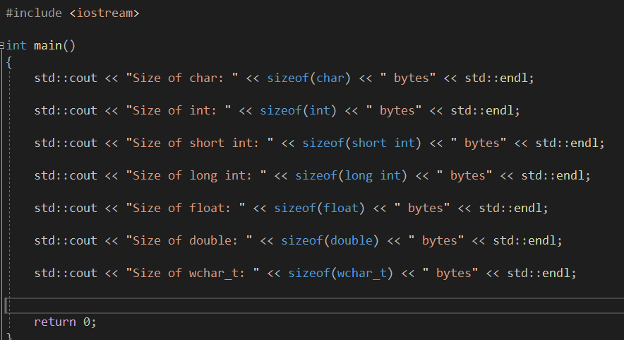

Program 2 Screenshot:
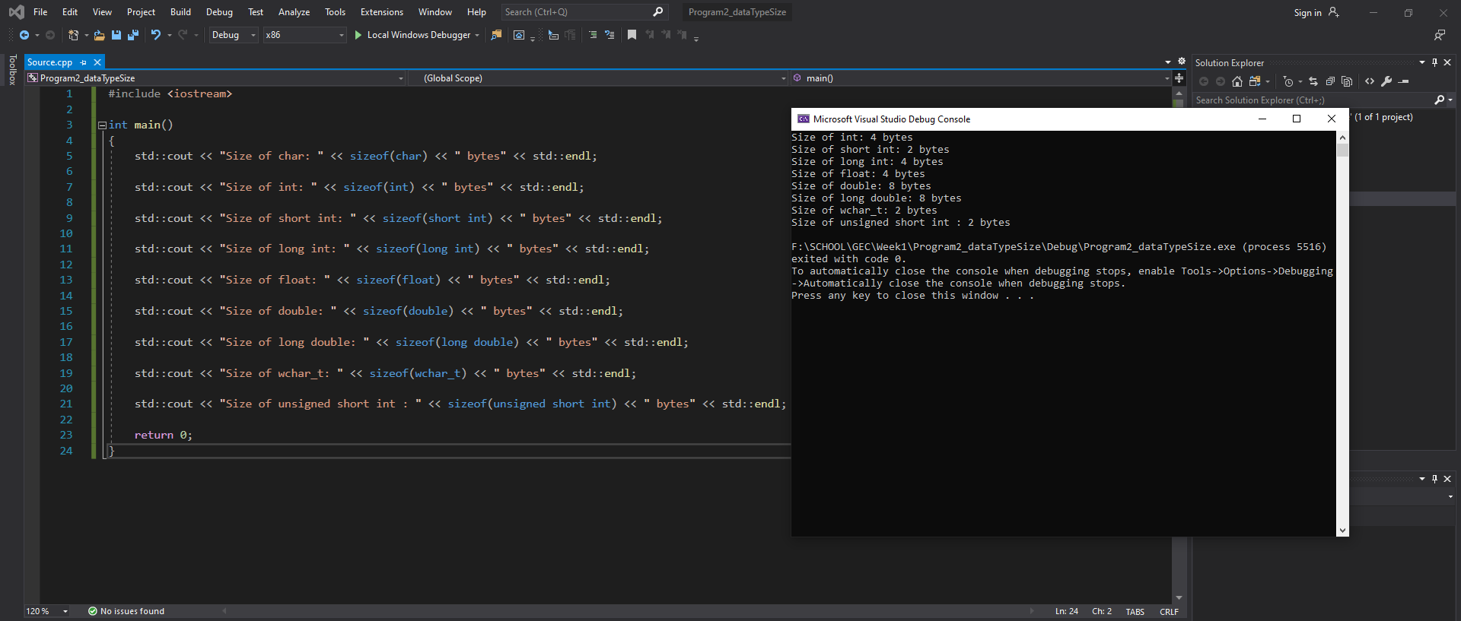

Declaring User Data Types
As mentioned above as well as the in-built types, C++ allows you to create your own data types by using the keyword typedef. The reason for doing is purely for the coder benefit and ease of reading. To the compiler your data type is no different form the original. The format for creating your own data type is as follows:
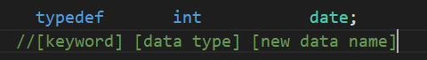
Note: this does not have to be int, this is just what is used for this example. Any data type from table 2.3 can be used.

Now instead of using the keyword int we could use our own defined type date like so:
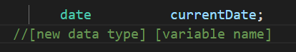
The above code is exactly the same as using int currentDate;
If, however you required a data type to represent several values we can create an Enumeration. This allows you to create a new type and assign the constant value it represents. It follows this format: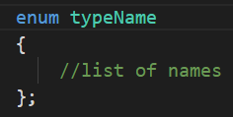
It will become clearer if we use an example. So, sticking with the date idea, in this example we would rather use the terms JANUARY, FEBRUARY, MARCH, etc to represent the month. We could create our own typedef month as shown above, but then in code we will always be using integer values. This is not very readable, so instead we will use an enumeration:
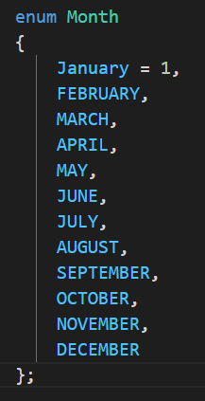
Note: Notice the syntax used when creating an enumerated type. After each type, a comma is used except for the last value and the semicolon is used after the curly brace.
As you can see JANUARY has been given the value of 1, and all the following names will be incremented by 1. For example, FEBRUARY will hold the value 2, MARCH the value 3, and so on.
You can set the value of any name, but it is important to remember that the following names will be incremented by 1.
It is also possible to set none of the names to an initial value. In this case the first name will be assigned the value 0, and the following names incremented in the usual way.

To use this enumerated data type, we create a variable of this type in the exact same way as we do any other.
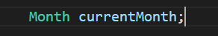

Chapter 3: Variable Types

A variable is storage in memory that we can access using a name of our choosing. All variables must be of a data type described in the previous chapter. That is because the data type informs the compiler how much memory is to be reserved and what values can be stored. Refer to Table 2.1 for the data types that can be used along with the keywords that must entered for C++ to recognise the type.
When defining a variable, the user chooses what to name it, but there are restrictions. The name can be composed of letters, digits and underscores, but the first character must always be a letter or underscore. It is good practice to make the first letter of each new word uppercase. For example, thisIsMyExampleVariableName. This can also be seen in the previous chapter where we named our variables currentDate and currentMonth.
Also, the name chosen should be something informative. Variables of this sort: a, b, or myVariable do not help in any way, if you are dealing with user’s names call it userName or if dealing with ages call it age. Also, there may only ever be one variable of this name. duplicating names will produce syntax errors.
One final thing to note is that C++ is case sensitive, so when using your variables throughout your code ensure that they match. You will receive a syntax error if they do not.
The most straight forward way to declare a variable is with the following format:
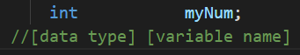
To assign a value to our variable myNum we use the assignment operator =. (Operators are covered in more depth in the next chapter.)
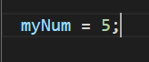
So, at this point wherever you use the variable myNum it will produce the value 5. You could however choose to assign the value of 5 at the same time as declaring the variable. This reduces the number of lines of code and makes the code easier to read. Bare in mind that you will not always know the starting value, so cannot do this.

So far so good. We have one last addition to make to this defining a variable section before we will get on to a mini program, and this is the use of definition lists. We can define multiple variables on the same line provided they are of the same data type. For example:
Variables can be changed as often as required. There is no special code required for this, you simply reset the variable to hold a different value.
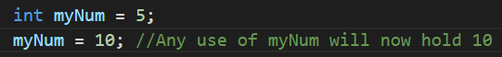
If you require a variable that will never change, then you can use the const modifier. This will make the value constant and can never be changed. You may think this unlikely to occur, but it is a feature that you will find useful more often than you may think. It is common to see a lowercase k before the variable name to signify that it is a constant variable throughout the code.
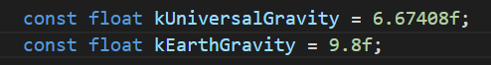
Note: Don’t forget if using float, it is good practice to add the f at the end of your value.

Program 3: Defining Variables
- To start, open Visual Studio.
- Create a new C++ console application as before and name it Program3_definingVariables.
- Next, replicate the following code (ensure when assigning a value to a char type you use single quotation marks).
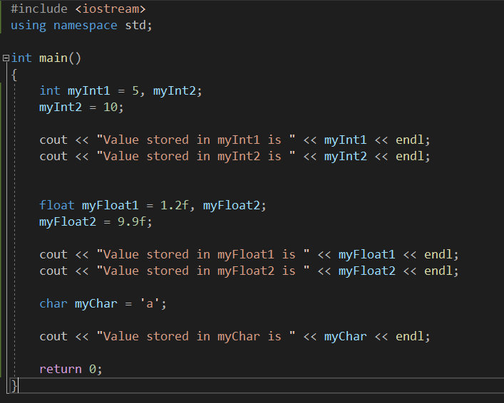

Program 3 Screenshot: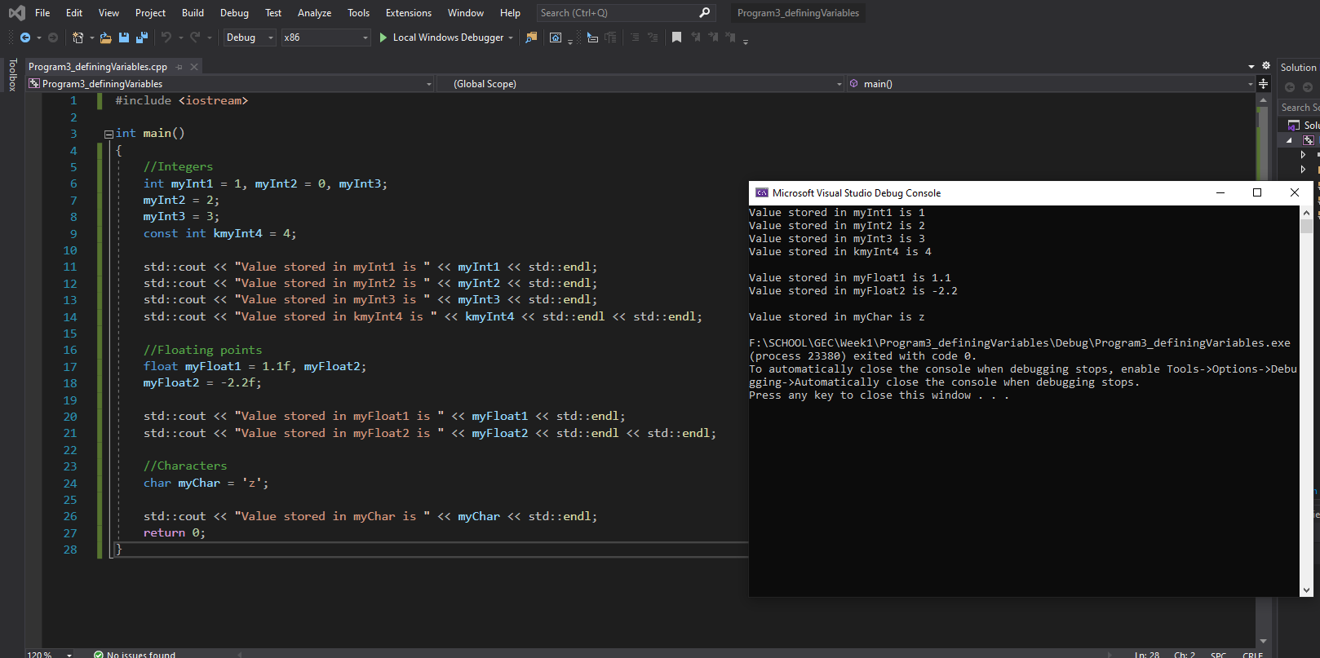
Program 4: Defining User-defined Variables
This program is for you to complete. Please pay attention to the instructions.
Create a program named Program4_userDefinedVars, this will contain both a typedef and an enum type. If you still have Visual Studio open, you can use the shortcut ctrl + shift + n
- Create a typedef of data type int named cost.
- Create an enumerated data type named CarMake, this list should contain the following cars in this order.
  - FORD
  - FIAT
  - TESLA
  - VW
  - BMW
  - ASTONMARTIN
  - HONDA
  - NISSAN
  - TOYOTA
  - AUDI
  - JAGUAR
  - DODGE
- Next create a variable of data type cost with the value of 13000, and a variable of data type CarMake with the value of HONDA.
Out the following to screen:
The cost of my car is: …
My car id is: …
HINT: You will need to pass the variables to the cout statement like that is program 3. Output should read: The cost of my car is: 13000 & My car id is: 7.

Program 4 Source code:
For testing purposes please follow these steps to adding code to this portfolio.
- Copy the code from within Visual Studio
- In word click Insert and then in the Text field click object
- In the dropdown popup select OpenDocument Text and click OK
- Paste your code in the new blank document that opens and close when done. ENSURE CURSOR IS IN THE RIGHT PLACE IN THIS DOCUMENT FOR WHERE YOU WANT YOUR CODE

Program 4 Screenshot:
As before this should be a screenshot of your output.
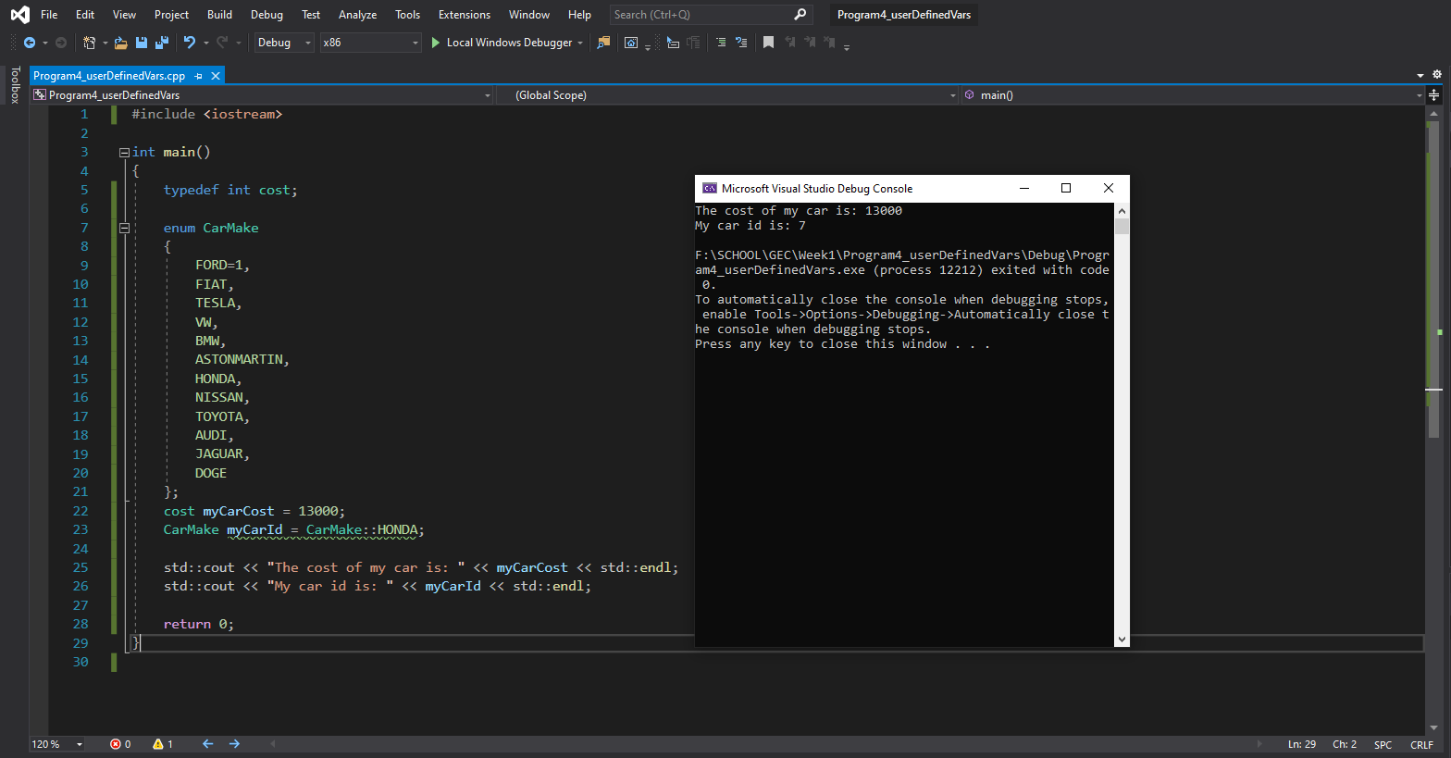

Chapter 4: Operators

Operators are special characters that represent mathematical or logical manipulations. C++ has a range of different operators, and we will be covering the following in this chapter: Mathematical Operators, Assignment Operators, Relational Operators, and Logical Operators.
Mathematical Operators
Looking at table 4.1 you will no doubt recognise the first four operators. These represent the usual mathematical operators we use in everyday life. As such we will not be explaining those, instead we will be focusing on the unfamiliar symbols.
Operator | Description
+ | Adds two operands
- | Subtracts second operand from first
* | Multiplies both operands
/ | Divides numerator by denominator
% | Remainder left after integer division
++ | Increases integer by one
-- | Decreases integer by one
Table 4.1: Mathematical Operators

Modulus
The following code snippet creates two integer variables which each store a number. The final line of code creates an integer variable named remainder which holds the remaining digits from a & b divided by a calculation.
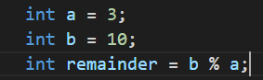
The variable remainder will be equal to 1 as 3 goes into 10 3 times with the remainder of 1.

Increment Operator
The increment operator adds 1 to the current value stored in the variable. This is simple enough and will be shown below. Confusion can arise when the increment operator is placed before the variable.
The following code snippet assumes the existence of an integer variable named num, which stores the value 1. After the following line of code, num will now be equal to 2.
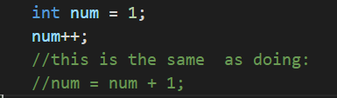
As stated above, the increment operator can be placed before the variable like so: ++num. This has the effect of changing the value stored in the variable in the same manner as before. But the effect takes place immediately. Assuming num started with a value of 1, in the above line of code, num will equal 2 as soon as it is reached, not on the following line.
Note: The placement of the Increment Operator may seem trivial or confusing now, but once we get to using loops in chapter 6 the placement will be crucial.

Decrement Operator
The decrement operator subtracts 1 from the current value stored in the variable. It works very much like the increment operator.
Again, the following code snippet assumes the existence of an integer variable named num, which stores the value 1. After the following line of code, num will now be equal to 0.
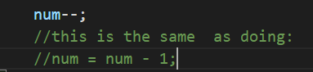
Just as with the increment operator, decrement can be placed before the variable. This has the effect of changing the value stored in the variable in the same manner as before. Assuming num started with a value of 1, in the above line of code, num will equal 0 as soon as it is reached, not on the following line.
Program 5: Increment / Decrement Operators
- If you haven’t already open VS and start a new project called Project5_IncrementDecrment
- Replicate the following code.
Note: It is a good idea to comment your code. This means to add comments, which are only there for the programmer’s benefit. The compiler ignores them. This may seem trivial, but it really helps other programmers who may use your code, or even yourself if you have not looked at a program in a while. To comment you can either use a double slash // or surround the text with a /* */ block. Both are demonstrated in the following code.
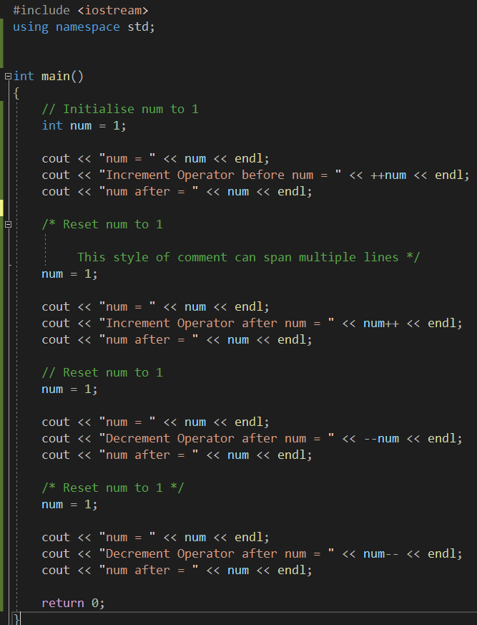
Program 5 Screenshot:
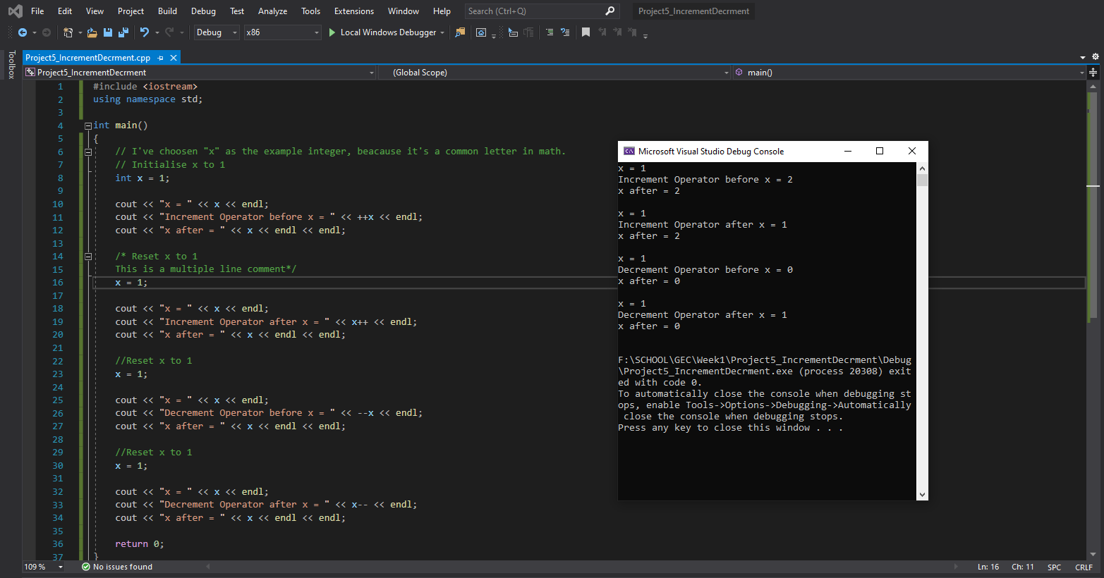

Program 6: Area of a Rectangle
This program is for you to complete. Please pay attention to the instructions.
- Create a program named Program6_area, which creates variables of integer data types for width and height. Initialise width to the value of 15 and the height variable to the value of 25.
- Next create an integer variable called area and set this to equal the width times by the height.
- The output should be in the following format:

Program 6 Source code:
As before, please ensure to copy your code via the insert object format.
Program 6 Screenshot:
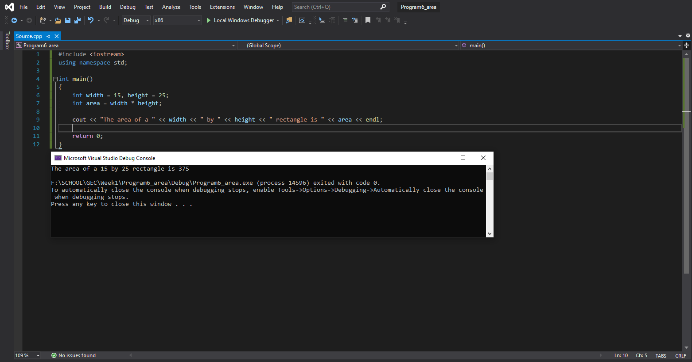

Program 7: Converting from Fahrenheit to Celsius
This program is for you to complete. Please pay attention to the instructions.
- Create a program called Program7_converting, in which you are required to write code that will convert Fahrenheit into Celsius
- Create two floating-point variables named fahrenheit and celsius, set the value of Fahrenheit to equal 95.0f.
- To calculate the Celsius, it must equal this formula: (Fahrenheit - 32) * 0.5556
- Output the results in the following format:

Program 7 Source code:
As before, please ensure to copy your code via the insert object format.
Program 7 Screenshot: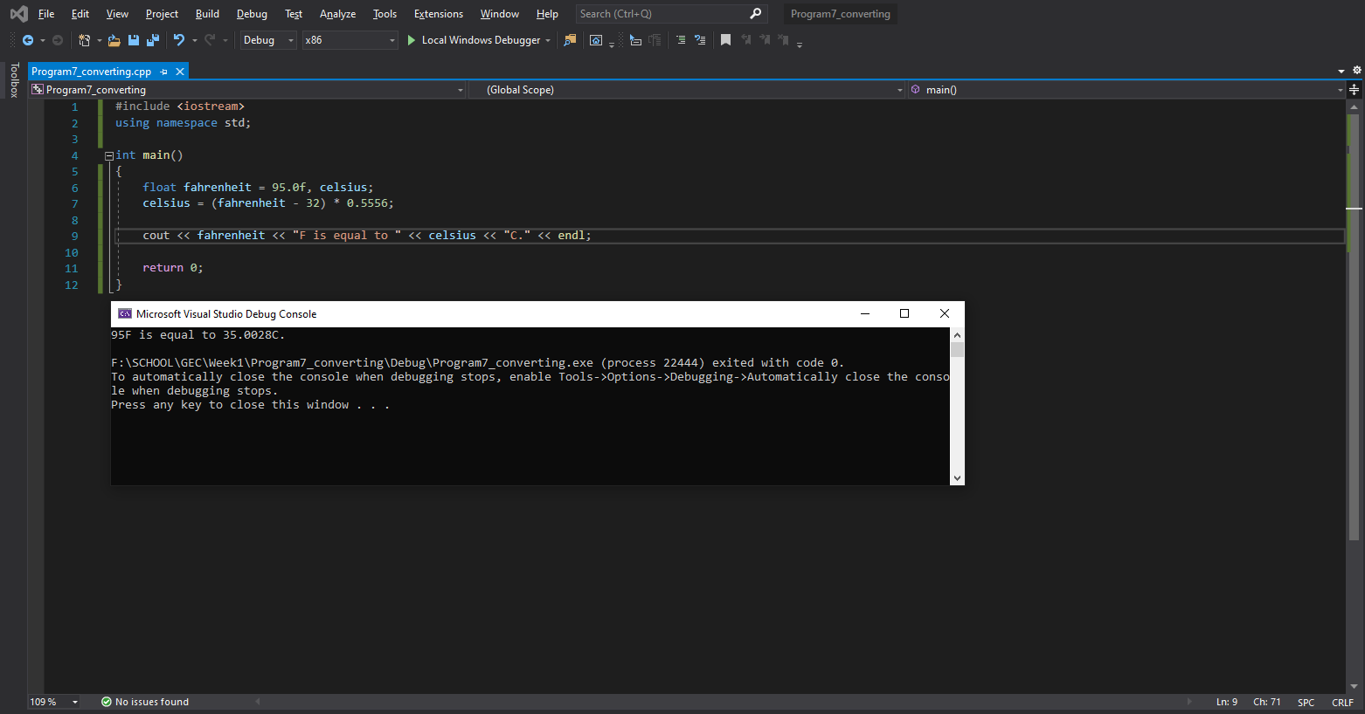
Program 8: Area of a Circle
This program is for you to complete. Please pay attention to the instructions.
- Create a program called Program8_pi, in this program we will calculate the area of a circle.
- Create a constant floating-point variable named pi, this will hold the value 3.14159.
- Next create two float variables, one called area and one called radius. Set the value of radius to equal 25.0f. And set the value of area to equal this formula: pi * radius * radius.
- Output the result in the following format:

Program 8 Source code:

Program 8 Screenshot:
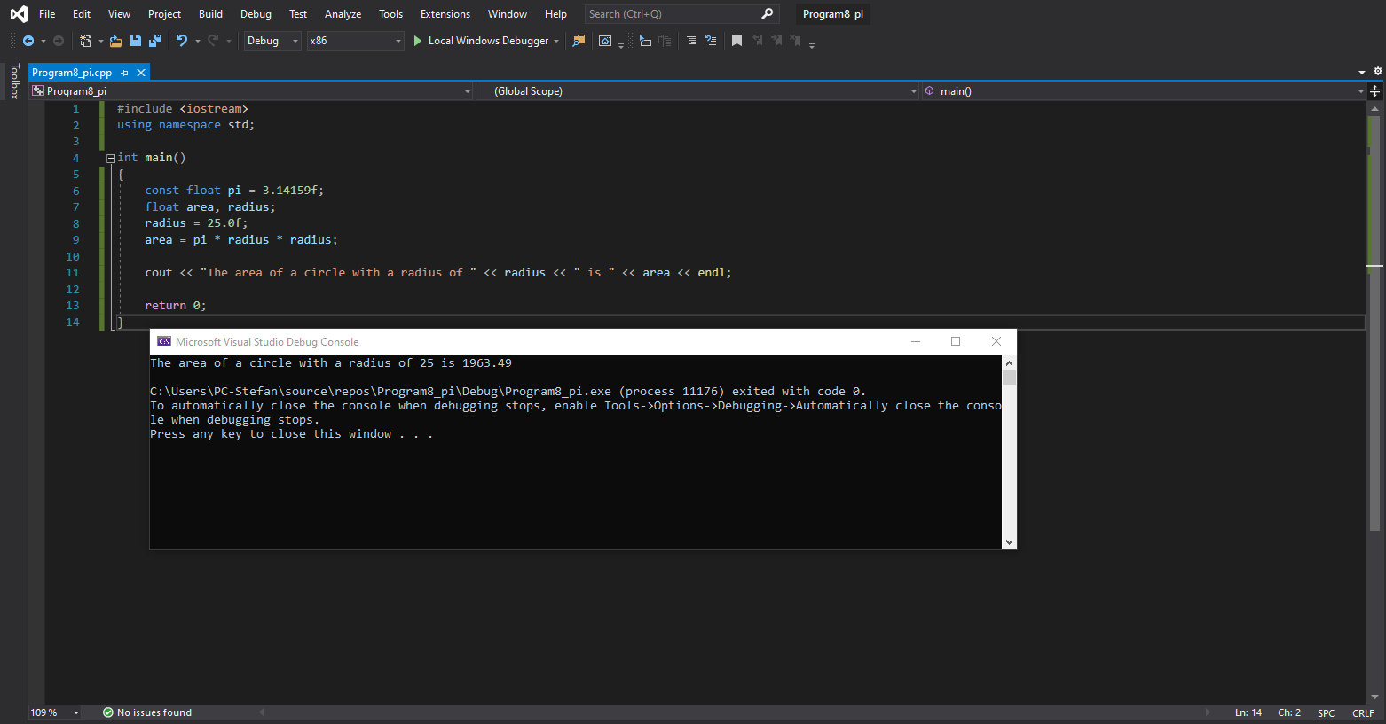

Assignment Operators
Now that we understand the mathematical operators, we can move on to assignment operators. These operators simply reduce the amount of code required to do a simple operation. Look at Table 4.2. Examples of each operator will follow below.
Operator | Description
= | Assigns value from the right-side operand to the left side operand.
+= | Adds right operand to the left operand and assigns the result to the left operand.
-= | Subtracts right operand to the left operand and assigns the result to the left operand.
*= | Multiplies the right and left operands together and assigns the result to the left operand.
/= | Divides the left operand by the right operand and assigns the result to the left operand.
%= | Takes the modulus of two operands and assigns the result to the left operand.
Table 4.2: Assignment Operators

Equals Operator
As has been shown previously the equals operator is used to assign a value to a variable. A variable must always be on the left-hand side of these operations. The following snippet assigns the value of 5 to the variable num.
You can also assign a variable to equal the value stored in a completely different variable provided they are of the same data type, like so:
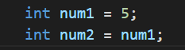

Calculate and assign
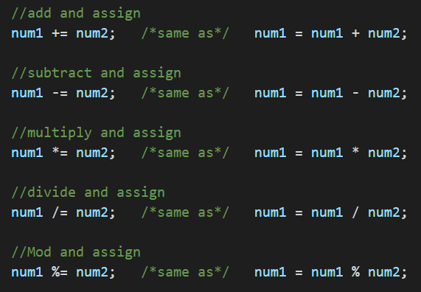

Rational Operators
Relational Operators are used to return a result of true or false. These will be used all the time in conjunction with conditionals [chapter 5 next week]. Look at Table 4.3 and the corresponding examples below for an explanation of each operator.
Operator | Description
== | Checks if the values of the two operands are equal, if so, the condition becomes true.
!= | Checks if the values of the two operands are not equal, if they are not equal then the condition becomes true.
> | Checks if the left operand is greater than the right operand, if so, the condition becomes true.
< | Checks if the left operand is less than the right operand, if so, the condition becomes true.
>= | Checks if the left operand is greater than or equal to the right operand, if so, the condition becomes true.
<= | Checks if the left operand is less than or equal to the right operand, if so, the condition becomes true.
Table 4.3: Relational Operators

Examples of Rational Operators
If the variables being compared store the same value the result returned will be true, otherwise it will return false. Take notice of how a single = sign is for assignment and the double == is for comparison.
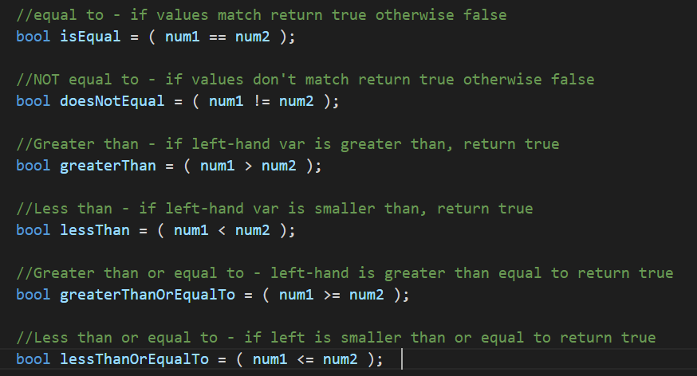

Logical Operators
Logical Operators are used to return a result of true or false. Just like Relational Operators, these will be used all the time in conjunction with conditionals next week. Look at Table 4.4 and the corresponding examples below for an explanation of each operator.
Operator | Description
&& | AND Operator  If both operands are non-zero [true], then the condition becomes true.
|| | OR Operator  If any of the two operands is non-zero [true], then condition becomes true.
! | NOT Operator  Used to reverse the logical state of an operand. If a condition is true, the NOT Operator will make it false.
Table 4.4: Logical Operators

Examples of Logical Operators
Logical AND checks if both variables being checked are true the result will be true, otherwise false will be returned. Whereas the logical OR checks if either of the variables being checked are true. If one of them is true then the result returned will be true, otherwise false will be returned.
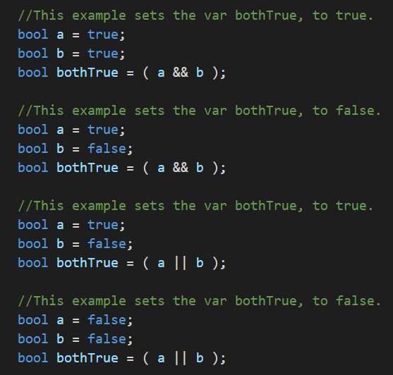

The Logical NOT operator will reverse the result from the other two logical operators. This may seem a redundant operation, but using the ! (NOT) operator will come in useful. The following two examples are the exact same as the examples used for Logical AND except that we have included the ! (NOT) operator. Notice how the results have been reversed.
